ABOUT page
The idea was ingenious.
But critics and coaches, even those at Texas A&M, ridiculed it and said it would never work.
Too risky.
Too much of a gamble.
It was a recipe for disaster.
Yet, Jackie Sherrill, in his second year as head football coach at Texas A&M, stubbornly stuck to his plan to implement a 12th man kickoff team, comprised solely of all-volunteer, non-scholarship, former high school athletes from the Aggie student body.

And, the 12th Man Kickoff Team, fueled by the heart of a bunch of over-comers, was born.

"If these kids are this tough and this crazy and give so much back to their school, then I can find 10 to go down the field on my kickoff team,” Jackie Sherrill in Sports Illustrated in 1983

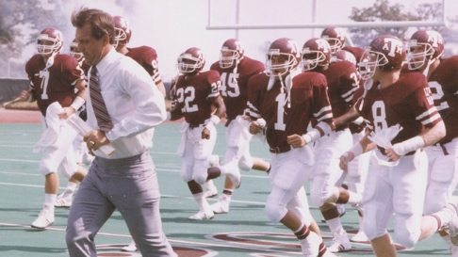

Fast-forward twenty-five years and Coach Sherrill had another great idea...he just knew would work.

Coach Sherrill challenged the men who had once taken the field for him as the legendary 12th Man Kickoff Team to “step out of the stands” once again. This time the goal was to serve their university in a different way, through providing scholarships, service and spreading Aggie love to a new generation of over-comers.

In 2008, the 12th Man Kickoff Team Foundation was officially formed.
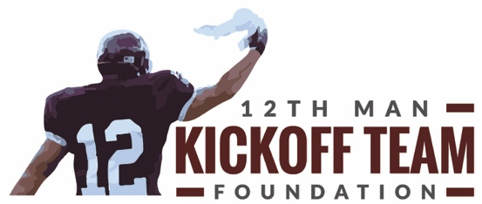

Over 80 players strong, the primary mission of the Foundation is to raise funds to award scholarships to students attending Texas A&M University. Just like the early teams, the Foundation is made up entirely of volunteers. Unlike the teams of the 80’s, there are no tryouts! Anyone and everyone who desires to make a difference, can become a member.

Everyone is welcome. Join the Team! (hotline to Join the Team page)

(Mission and Vision statements at bottom of this page)

